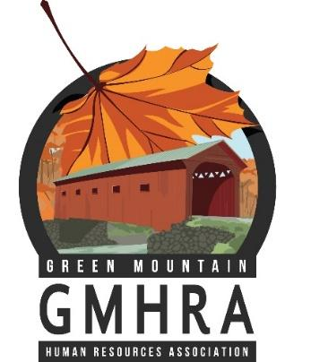
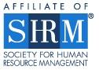
Green Mountain
Human Resources Association
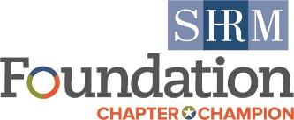
Thursday, October 20, 2022
9:00 am to 11:00 am

Extinguishing Burnout By Rediscovering Your Why Through Play

Webinar INFORMATION
Date: | Thursday, October 20, 2022
Speakers: | Jeff Harry
Place: | Zoom
Time: | 9:00 am – 11:00 am
Topic: | Extinguishing Burnout By Rediscovering Your Why Through Play

MEETING AGENDA
9:00 – 9:05 am | Meet and Greet
9:05 – 10:00 am | Presentation
TOPIC INFORMATION
Burnout is at an all-time high, yet most proposed solutions focus on analyzing burnout rather than finding answers for it. What if the answer is finding your why through play? Life demands a lot from us, but are we creating space for ourselves to do our best work and enjoy the journey? Studies have found that we are 500% more productive when we are in a state of flow. Also, being in flow provides a certain level of fulfillment and joy, as we learn to appreciate the process over the results. In this interactive workshop, you will learn how to use positive psychology techniques to help find your why, explore your play values, and rediscover actionable ways to get into flow, so you can be and do your best work.
Learning Objectives
- Identify why we are currently experiencing a burnout crisis
- Reconnect with our why at work & tap back into our flow
- Identify actionable strategies to do the work that makes us come most alive


Jeff Harry— Rediscover Your Play
Jeff Harry combines positive psychology and play to heal workplaces, help teams build psychological safety and assist individuals in addressing their biggest challenges through embracing a play-oriented approach to work. Some of the topics he covers include how to dismantle toxic masculinity in the workplace, how to navigate the Great Resignation & uncertainty through play, how to deal with toxicity in the workplace, how to address the BS of office politics, how to tackle difficult conversations at work, how to play with your inner critic, and how to help your staff rediscover their flow. For his work, Jeff was selected by BambooHR & Engagedly as one of the Top 100 HR Influencers. His work has most recently been featured in the NY Times, Mashable, Upworthy, Shondaland, & Wired. Jeff has worked with Google, Microsoft, Southwest Airlines, Adobe, the NFL, Amazon, and Facebook, helping their staff to infuse more play into the day-to-day. You can check out his work here: https://rediscoveryourplay.com/speaking

Please register at: https://gmhra.com/meetinginfo.php
All credits for HRCI and SHRM will be provided via certificate at the end of the program.

